Shabbos Stories for
Parshas chukas 5779
Volume 10, Issue 47 10 Tammuz/ July 13, 2019
Printed L’illuy nishmas Nechama bas R’ Noach, a”h

For a free subscription, please forward your request to keren18@juno.com

Shabbos Conditions
By Rabbi Avi Kosman

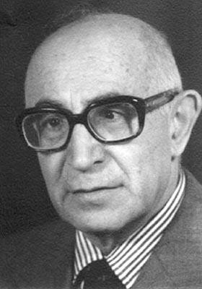
Yehoshua Rabinowitz, Mayor of Tel Aviv, 1969-1974

For one large, yet poor family living in Israel, it was a struggle to make ends meet. Yet, despite the small one and a half room apartment and other limited amenities, the family remained happy.
As time passed, though, and the family members continued growing up, the parents felt that there would be no choice other than to expand their apartment by adding on another room. And so, they proceeded with the project. But it wasn’t too long before they were met with distressing news: they would have to demolish their new room as it was built without licensed permission.
Disheartened at the news and unsure what the future would hold, the parents approached their Rav, Rav Shmuel Feldman, head rabbi of the shul Heichel Meir in Tel Aviv. Rav Feldman told them that he would see what he could do to help. He was in fact related to the mayor of Tel Aviv, Yehoshua Rabinowitz, who would perhaps be able to prevent the demolition.
Returning back to the parents shortly thereafter, Rav Feldman looked disappointed. “I am sorry,” he said, “but although the mayor could legally waive the violation and allow you to keep the room intact, he would rather keep to the city’s regulations and not make any special considerations.” With nothing left to say, the parents returned home sorely distressed.

“Let Me See What I Can Do”
A week later, Benzion Feldman, son of Rav Shmuel Feldman, was approached by the parents. “Benzion,” they said, “maybe you can help us. We built an extra room in our house because we desperately needed the space. It however is set to be demolished very soon. Your father already tried asking your relative, the mayor, to help us, but it was to no avail. Do you think you could assist us in any way?” After thinking about it for a moment, Benzion replied, “Let me see what I can do.”
A few days passed until it was Shabbos. As was the case, the mayor, Yehoshua Rabinowitz, used to take his dog for a walk every Shabbos morning as droves of religious Jews would make their way to shul. Despite not being religious, Yehoshua Rabinowitz though was a knowledgeable man.
He had years before attended the Telz Yeshiva in Lithuania, although he had later come to Israel and given up on Judaism. Notwithstanding, he respected the erudition of young yeshiva students who dedicated their time and efforts to learning Torah. And so, when he saw his young relative, Benzion Feldman, who he knew was taking great strides in his Judaic studies, he perked up.
“Oh, Benzion, how are you doing?” the mayor asked. “I am doing fine,” replied Benzion. “I haven’t seen you in quite a while,” continued the mayor, “is there anything I can help you with?”

“I Have a Favor to Ask of You”
“As a matter of fact,” began Benzion, “although I do not normally make requests of you, now I have a favor to ask of you. There is a family who has been told that they must demolish a room they added to their apartment.”
Hearing the first few words of Benzion, the mayor immediately interjected. “You can stop right there. I already know the story; your father came to me with the same request. I am very sorry, but I cannot help you with regards to this.” Listening to the unequivocal response, young Benzion stood there.
And then Benzion began to plead. “But you must help this family! They don’t have enough room for their family to fit!” Listening to Benzion’s sincere request, the mayor’s heart went out for the family.
After thinking for a minute, the mayor capitulated. “Okay, let me see what I can to help the family.” Benzion’s face immediately brightened up. “But,” continued the mayor, “if I choose to do so, I would like to add one condition. Please do a favor for me in return. I haven’t learned Torah in many years and I have been out of touch with Judaism. But, if you could, please learn Torah for an extra fifteen minutes a day in my merit.”
Benzion stood their quietly. “Okay, I agree to do so. But if you are going to make a condition with me, I would like to make a condition with you. I will learn for an extra fifteen minutes a day if you observe Shabbos every week for fifteen minutes.”

“I Smoke, and Besides I Am a Very Busy Person”
Now it was the mayor’s turn to respond. “I would like to keep Shabbos, but I don’t think I will be able to do that! I smoke, and besides I am a very busy person.” “A deal is a deal,” said Benzion. “I will learn for you if you keep Shabbos for fifteen minutes.”
Figuring that such a condition would not easily be changed, the mayor came up with an idea. “I’ll tell you what. I’ll wake up at 6:45 am instead of 6:30 as I do every morning, and during that time I am sleeping, I will be keeping Shabbos for fifteen extra minutes.”
“I am sorry,” said Benzion, “but you have to be awake while you keep your side of the deal.”
With no other option in mind, the mayor finally relented. “Okay. I will remain awake and not violate Shabbos every week for fifteen minutes if you learn for me for fifteen minutes every day. But on one condition: I want you to learn a special Mesechta (Talmudic Tractate) in my merit. I want you to learn Mesechta Shabbos. If I keep Shabbos, I want you to learn about Shabbos for me.”
“You have a deal,” said Benzion. And with that they shook hands.

The Mayor Fulfilled His Commitment
The extra room that the poor family had added on was never demolished. The mayor fulfilled his commitment and received in return the merit of Mesechta Shabbos being learnt every day for him. And indeed, the next time Mayor Yehoshua Rabinowitz met the Chief Rabbi of Israel of the time, he proudly said, “I want you to know that I observe Shabbos for fifteen minutes every week just like you.”
Every Jew has a connection to Yiddishkeit. For some, it may be more apparent and for others less apparent. But we all deep down have a beautiful neshama which yearns to connect to our Father on some level. In this case, the mayor demonstrated that within the depths of his soul, he valued learning Torah and the observance of Shabbos. And indeed, every little stride taken in Yiddishkeit is greatly endeared by Hashem. Yes, even fifteen minutes.

Reprinted from the Parashat Naso 5779 email of The TorahAnyTimes Newsletter as compiled and edited by Elan Perchik

Rav Shach’s “Fan” Letters

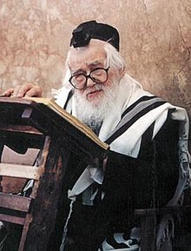

A certain Rav was having a hard time taking on a particular issue that was affecting many people, and he was trying to get people to change. People did not take well to this, however, and they would degrade and belittle this Rav. Worse than this, though, was that these people began insulting, embarrassing, and cursing this Rav’s wife.
It reached a point where the Rebbetzin could not handle the harsh treatment anymore, and she asked her husband to leave his position as a Rav. The Rav responded that before they did anything like that, he wanted them to go ask Rav Elazar Shach, zt”l, what he thought they should do.
When they met with Rav Shach, the Rebbetzin tearfully told him all the abuse and terrible treatment she had been enduring lately.
Rav Shach said to her, “You are bothered by mere words?” Rav Shach got up and walked over to his closet. He took out a big pile of letters that were written in protest of him that he had accumulated over the years. He said to the Rebbetzin, “If I took to heart anything that is written in these letters and listened to them, I would not be a Rosh Yeshivah today, and I certainly wouldn’t be able to help manage the struggles that the Yiden are facing.”
The Rebbetzin said to him, “If I may ask, why does the Rav keep all these letters in the closet? Don’t they cause pain to even see them?”
Rav Shach replied, “I have requested in my will that after I pass away from this world, that all these letters be placed in my grave, because all of these disgraceful letter that have come to me over matters that I am pursuing L’Sheim Shamayim, for the sake of Hashem, should stand as a Zechus, a merit for me when I stand trial in the Bais Din in Shamayim!”

Reprinted from the Parshas Shelach 5779 email of Torah U’Tefilah: A Collection of Inspiring Insights compiled by Rabbi Yehuda Winzelberg.

“If It Will Encourage Another Family, It Is Worth
All the Time”
By Rabbi Sholom DovBer Avtzon

Being that this Sunday the 27th of Sivan is the yahrzeit of my mother Cheyena Avtzon a”h, I am posting a chapter of her fruitful life.

In November 1953, my parents arrived from Europe, under the auspices of HIAS, and settled in Detroit, Michigan. Coming there was somewhat of a culture shock. Among other things, Cholov Yisroel was non-existent, and my father polished up his shechitah of chickens (which he had learned in Russia, but didn’t really practice), so there would be fleishigs in the house. He was the only Jew in town with a full beard, and my mother was one of three women who wore a sheitel.
Taharas hamishpachah was kept by some additional families, but sadly there were not enough people who observed it to show the communal leaders that it was a priority. Subsequently, the one mikvah was not kept up to par, and quite often my mother would go there herself to clean it.
Her efforts bore fruit, as one woman told another that Mrs. Binah (as my mother was then called) made sure the mikvah was clean, and more families began using it. A few years later, they formed a committee to spruce it up.
A brochure was prepared and signed by the Jewish Orthodox Women’s Mikvah Committee. As with all of the numerous peulos (activities) she was involved in, she sent a copy of the brochure to the [Lubavitcher] Rebbe.
The Rebbe replied that the word Orthodox should be removed. He explained that there are many women and families who don’t consider themselves Orthodox, yet they keep or would be willing to keep taharas hamishpachah. By stressing that this was an Orthodox committee or project, the committee might inadvertently cause them to refrain from participating. The brochure was redone, and the Rebbe’s words were indeed realized: many women who didn’t consider themselves Orthodox frequented the mikvah.
Years later, in the mid 1960’s, as the Jewish community began moving to the outskirts of the city (Oak Park), my mother saw the tremendous need to build a new mikvah there. She convinced the committee to build a mikvah there, although that area was then the outskirts of the city. Now, over fifty years later, it is the prime location of the Jewish community.
During one of her many yechidusin [meetings], the Rebbe inquired in detail about the progress in the planning and design of the mikvah. When they discussed the tiles, my mother mentioned that she had a friend who promised to buy them for the mikvah. The Rebbe instructed her to convince the friend to buy tiles imported from Italy, explaining that it would create a tremendous sense of prestige and could convince additional people to use the mikvah. He even asked about the color of the tiles, stressing that they be light-colored and feminine.
After answering the first few questions, my mother said, “I don’t want to waste the Rebbe’s time on such insignificant points.”
The Rebbe firmly replied: “If this will encourage even one more family to keep taharas hamishpachah, then it is worthwhile to spend as much time as necessary.” When my mother didn’t bring up any additional points, the Rebbe continued the conversation by asking her about the towels etc., emphasizing that they should be of superior quality and should match the color of the tiles.
As far as we know, this was the most modern mikvah to be built at that time, and indeed many women who were informed about its beautiful and calming design came to see it and began using it. Indeed, when others were considering to build mikvaos for their communities, the Rebbe suggested that they follow the guidelines he gave for the mikvah in Detroit.
Even after the new mikvah was built, although it had its own committee, she continued to take care of so many details relating to its maintenance and upkeep. However, she always encouraged others to become involved and gave them the credit. To her, the only points that were important were, “Does the Rebbe want this to be accomplished?” and, “Are more families benefiting from it?”
Nonetheless, after her petirah in 5746 (1986), the community decided to give her the recognition she refused to accept during her lifetime and affixed a plaque thanking her for her decades of service and dedication.

This weeks’ story is being posted in honor of the birth of our new granddaughter, Devorah Leah bas Chaya Mushka, l’arichus yomim v’shonim tovos.

(Reprinted from the Parshas Shelach Weekly Story email of Rabbi Sholom DovBer Avtzon, a veteran mechanech and the author of numerous books on the Lubavitcher Rebbeim and their chassidim. He is available to speak or farbreng in your community and can be contacted at avtzonbooks@gmail.com)

The Second Meshullach
In the Shul
By Rabbi Dov Brezak

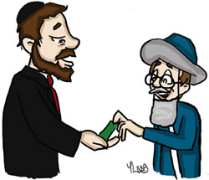

Harav Elimelech Biederman brings the following in his Be’er Haparsha Shlach-Israel 5779.
One who walks with complete faith will walk confidently especially when he remembers that everything that happens in this world has been decreed from above.
No one else can distance from me, nor bring close to me, my salvation or my needs, whether the matter is spiritual physical or monetary.
s Listen to the story that one of my friends from Beit Shemesh shared with me.
`My friend (let’s call him Reb Shlomo) had to marry his daughter and since his house (and wallet) were truly empty he decided to travel overseas in the hope of collecting the amount needed. In addition he would give our brethren in the diaspora the merit of the great miztva of hachnasas kalah. (We stress that this person truly had no way of marrying off his daughter and the situation was a dire one indeed.)
He made sure to reserve a driver, one of those that had experience in taking solicitors (meshulachim) from here to there and from there to here.
When the time came Reb Shlomo had to share the driver with another meshulach who was also collecting (let’s call him Reb Ploni). Reb Ploni was a rough fellow and he gave Reb Shlomo explicit instructions that he is not to enter any shul or beis hamedrash they come to for collecting, until after Reb Ploni has finished his collecting first and has left the premises. Only then does he permit Reb Shlomo to enter and to collect for himself.
Although Reb Ploni’s demands were entirely outrageous and full of nerve Reb Shlomo was quiet and accepted the heavenly decree with love.
The next day, things proceeded as usual. They came to a shul, Rav Ploni went in first, finished his rounds and came out. Only then did Reb Shlomo enter the shul, but this time when he came out he was very happy.
He did not disclose the reason for his happiness but when they came to the next shul and Reb Ploni went in to make his rounds, Reb Shlomo then revealed the reason he was so happy. He turned to the driver and showed him a check he had received for $1800.
(Please understand that the standard donation for this type of collection is anywhere from 25 cents to 1$. DB)
The driver, who knew the author of the check, was very puzzled. He knew this person well and he knew that he was not particularly wealthy.
The driver contacted the person who wrote the check and that person explained to him that he had just recently made a very successful business deal. Because of this success he accepted upon himself that he will give a tenth of the profits to the first person in need that comes his way.
The perplexed driver asked the man about Reb Ploni who came in first but the man did not know what he was talking about. Through the conversation it became clear that at the time Reb Ploni was making his rounds, the author of the check was in the bathroom.
The conclusion? Reb Ploni was sure that through his control of the situation he will certainly be taken care of. He made sure to be the first one collecting so that he will get the better donations. Yet what he didn’t realize was that Hashem controls the world not him everyone will get what is decreed for them without anyone else be being able to prevent this.
It was precisely his trying to make sure that he get the better deal by going in first that brought his friend to receive the $1800 check.

Reprinted from the Parshas Be’halosecha [Chutz La’aretz] email of Shehakol Nihiye Bidvaro.

Reflections on Riding
On a Comfortable Train



Early one morning, the Rebbe of Radishitz zt’l said, "A special guest arrived today. It's his first visit. He won't be here again, so I want to honor him properly. The guest is Today. It came today, and it will never come back…"
Time must be utilized properly, because time wasted is forever gone. Someone was waiting for a train in a Swiss train station. The train arrived, but he didn't board it. His friend asked him, “Why don’t you board the train?”
The man replied, “This train isn’t very comfortable, but the next train is luxurious. Every passenger gets his own table to eat on and a berth to sleep in… I'm waiting for that train.”
“But that train won’t be here for many hours…”
He replied, “That’s o.k. It's worth it for me to wait.”
The train finally arrived and he boarded it joyously. He enjoyed a good meal at the table. And then, exhausted (from waiting in the sun for so long) he lay down and slept for several hours.
When he awoke, he realized he boarded the wrong train. He traveled in the wrong direction! It was too late to seek a train to bring him home. It was almost Shabbos. He didn’t even have Shabbos clothes to wear! He sought a place to stay for Shabbos.
This happened because he was so focused on attaining physical pleasures that he forgot to take careful note of other essential matters, such as where the train was headed.
When a person’s primary focus is to attain pleasures in this world, he will lose sight of the primary purpose we came to the world. He is interested in worldly pleasures and forgets to be careful with sparing time for Torah and mitzvos.

Reprinted from the Parshas Shalach 5779 email of Torah Wellsprings: Collected Thoughts of Rabbi Elimelech Biderman.

The Doctors and G-d’s Will

Reb Leibke Glauberman zt'l was one of the Yerushalayimer tzaddikim . (In his younger years, he was among the chassidim of the Yanuka zy'a, Rebbe Yisrael of Stolin zy'a). In his old age, his legs were ill, and the doctors in the hospital decided they must amputate them.
Reb Leibke accepted Hashem's decree, and he was brought in for the operation, while his children waited outside the operating room. After the operation, a doctor told the children that they made a mistake; the operation wasn’t really necessary.
They could have saved his legs. "But it is too late now," the doctor said, "What's done is done." Reb Leibka's children were angry with the doctors for making this terrible error. When Reb Leibka woke up they told him that it was all a mistake. "Your legs didn’t need amputation." Reb Leibke replied, "I heard from my holy Rebbe, the Yanuka:, to say ‘If only I would have done things differently…’ is apikorsus [heretical].
“Everything is destined from heaven. The doctors may say that an illness such as I had didn’t call for an amputation. But my foot needed to be amputated nonetheless, because that was decreed from Above. Fact is that this is what happened to me. It wouldn’t have happened if it wasn't Hashem's will."

Reprinted from the Parshas Shalach 5779 email of Torah Wellsprings: Collected Thoughts of Rabbi Elimelech Biderman.

Judging Favorably #44
The Fisher Price Gas Station

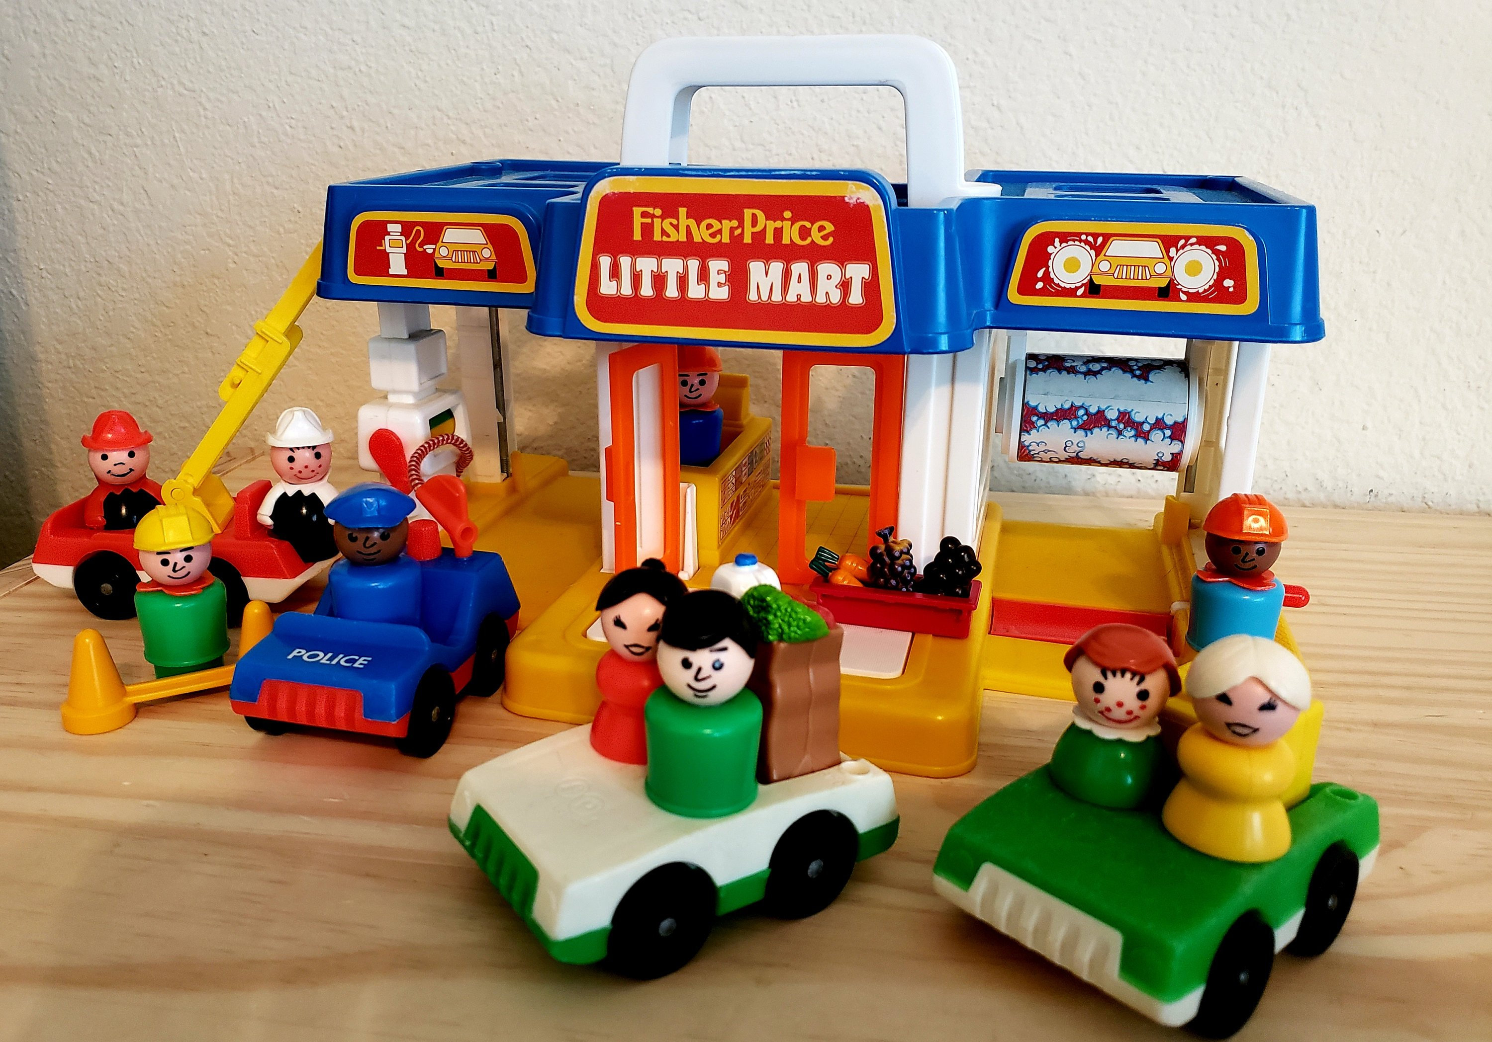

My young son was housebound after an operation and I asked my sister-in-law to send me her Fisher Price gas station to keep him occupied. She couldn’t find someone to bring it from her home on the other side of town.
I was a bit desperate, so, against my better judgment, I decided to borrow the toy from a neighbor who lives across from us. This neighbor is much more successful than I am in keeping toys looking like new, and the garage was in excellent condition. We guarded it very carefully.
A few days later, this neighbor came in, barely able to contain her anger. She accused me not only of making a shmattah of her gas station, but of being so cowardly as to just leave it next to her front door without a word of apology.
I was stunned! I went into the other room and brought out her gas station intact and exactly as I’d received it. Now we were both mystified. She returned home and came back carrying a bruised and battered gas station, which I immediately recognized as my sister-in-law’s!
Later we found out that my sister-in-law had finally found someone to bring the toy. The messenger found our door locked and left the toy near the door. The man who cleaned the building that day had pushed the toy the short distance to my neighbor’s apartment across the hall! (The Other Side of the Story)

Reprinted from the Parshas Korach 5779 email of The Weekly Vort. Excerpted from “The Other Side of the Story by Yehudis Samet.)

Sometimes we convince ourselves, “I cannot learn.” But we mustn’t ever feel that way. Each and every one of us holds the potential to rise to the occasion and become the greatest we can become. Torah has the power of propelling us to the loftiest of heights and opening new doors which we never knew existed. And when that occurs, we no longer need to place our foot in the door, because this time, it stays wide open.

Reprinted from the Parshas Nasso 5779 email of The TorahAnyTimes Newsletter as compiled and edited by Elan Perchik

A Story About a Salesman And Life’s Purpose
By Leibel Gniwisch
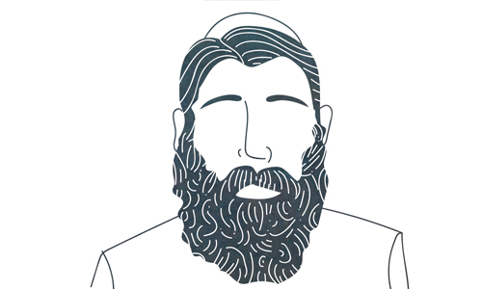

The haze was thicker than usual—a mixture of cigarette and furnace smoke—but Rabbi Shmuel could see the man. It was Belarus in the 19th century and Jewish-run inns dotted the rural areas like poppy seeds on a bagel. Rabbi Shmuel didn’t frequent inns; he preferred the comfort of his straw bed at home. But his people needed him so from time to time he swapped his wife’s cooking for the stuff they called food here.
You know when you see an interesting stranger and want to approach him but don’t because you’re afraid of the awkwardness and rejection? Rabbi Shmuel felt the same.On the first night of his stay, Rabbi Shmuel noticed an interesting stranger. Rabbi Shmuel couldn’t help but analyze him: “He’s stately, well dressed. He has an inner calm that I don’t see often.” But Rabbi Shmuel was most impressed by the man’s glow; he sensed a holiness in the man. While Rabbi Shmuel wanted to know the source of the man’s aura, he couldn’t approach him. Speaking with strangers can be difficult.
Night two at the inn found Rabbi Shmuel tired from a long day of activities on behalf of the Jewish community. Weary, he opened his Talmud to learn before he retired. “Why would the defendant be obligated to take an oath in this case?...” There the man was again. Sorting through documents in his attache case, his presence illuminated by contentment. “I must approach him tonight,” Rabbi Shmuel decided.
But he didn’t because he wanted to finish learning and by the time he was done, the man had gone back to his room. “Tomorrow night,” Rabbi Shmuel said. He would discover the source of this man’s holiness.
The haze was thicker than usual, a mixture of cigarette and furnace smoke, but Rabbi Shmuel had no trouble finding the man. “Sweet Yid! Vos macht a Yid? (How are you?)” Rabbi Shmuel asked, approaching the man with slow determination.
The man looked up. He was eating soup. “I’m doing well, Rabbi.” He noticed that Rabbi Shmuel was a rabbi. “Can I ask you something?” the Rabbi asked.
“Of course!”
“Who are you?”
The man wasn’t perturbed by Rabbi Shmuel’s forwardness. “I’m a simple man. I sell shoes for a living. I’m doing well, thank G-d.”
“I mean, what do you do spiritually?” He was concerned with the man’s holiness. “How long do you pray? How much Torah do you study?”
“I don’t pray. I mean, I try to but I don't know how to read so I’m able to say the Shema by heart but nothing else. Same goes for learning.” The man cast his gaze downward.
Rabbi Shmuel didn’t judge the man. How could he? “I’m sorry to ask, but can you tell me about your day? I see something in you that I don’t usually see.”
“Of course, Rabbi. But I’m afraid that I’m quite ordinary. I wake up at 5 am every morning...” said the man as he launched into a detailed review of his day. He was nearing late afternoon and Rabbi Shmuel was still at a loss. Why did the man glow?
The man concluded, “And before I go to sleep I say to G-d:
“Master of the world, I ask only one thing from you. If I don’t have what it takes to fulfill the mission for which you created me, don’t wake me up tomorrow. Wake me up only if you believe I can do everything you need me to do in the world.”
Rabbi Shmuel had his answer.
Reprinted from the Parshas Korach 5779 email of Chabad.Org Magazine. As heard from Rabbi Shlomo Katz. Rabbi Shmuel is Rabbi Shmuel Weinberg of Slonim (1850-1916), author of Divrei Shmuel.
The Sages through the Ages

The Rambam
By Dr Benji Schreiber
The Rambam Córdoba, Almoravid Empire 1135 – Cairo, Egypt 1204

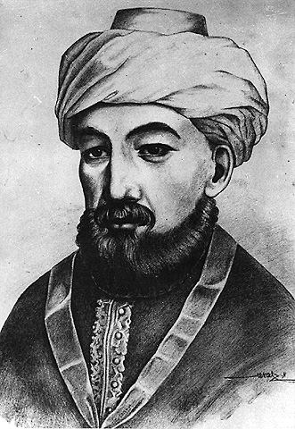

Rav Moshe ben Maimon, the Rambam, is undoubtedly one of the most influential sages Jewry has ever had. He was born in 1135 (or possibly 1138). He studied under his father, Rav Maimon, who learnt from Rav Yosef Ibn Migash – the Ri MiGash, who in turn was a talmid of Rav Yitzchak Alfasi, the Rif.
He [also] learnt mathematics, medicine and philosophy. The Golden Period of the Jews in Spain came to an end when the Almohads, a Berber Muslim movement from Morocco, conquered Córdoba in 1148, threatening Jews with conversion to Islam, death or exile.
Rambam moved many times, settling in Fez, Morocco. In 1165 he went to Acco, in Eretz Yisrael. He visited Yerushalayim, Har HaBayis, and the Maaras HaMachpela in Chevron.
Five months later the family moved to Egypt, living initially in Alexandria and then in Fustat, ancient Cairo. There he married and had his son Avraham, the only child who survived to adulthood and was awarded the position of Rais Al-Yahud, head of the Jewish community.
For many years he was supported by his brother, a precious stones merchant. When his brother drowned at sea in 1177, the Rambam had deep depression and took to his bed for a year. He then worked as a physician and from 1185 was personal physician to the Grand Vizier Al Qadi al Fadil, and then to Sultan Saladin.
In a famous letter, he described his daily routine. After visiting the Sultan’s palace, he would arrive home exhausted and hungry, where, he said: “I would find the antechambers filled with gentiles and Jews ... I would go to heal them, and write prescriptions for their illnesses ... until the evening ... and I would be extremely weak..”
He died in Cairo and was reinterred in Tiberias. His son, Avraham succeeded Rambam as Nagid and as court physician at the age of eighteen. Throughout his career, he defended his father’s writings against all critics.

Works
We have three major works from the Rambam and several important letters. From age 23-30, while living in Morocco and moving frequently, he wrote a commentary in Arabic on the whole Mishnah known as the Peirush Hamishnayos, this can be found in Lashon Hakodesh at the end of every masechta of Shas.
In recent years it was retranslated from the original Arabic by Rav Yosef Kapach. It was the Rambam who codified the famous thirteen principles of faith in his commentary at the end of Maseches Sanhedrin.
In his Mishneh Torah, he wrote an exquisitely clear and well-structured codex of all Jewish law. Unlike many other sefarim, he codifies Halachos that are not relevant nowadays, including all the laws pertaining to the Beis Hamikdash and Korbanos. It was set into fourteen volumes and is therefore also known as the Yad Hachazakah. He intended for this to be the final word in Halacha.
In fact, many of his rulings are debated by subsequent authorities and ‘The Rambam’ been pored over and analysed in hundreds of commentaries. However despite this, it forms a core source for contemporary halacha with the Shulchan Aruch citing and following his rulings extensively.
His Moreh Nevuchim, Guide for the Perplexed, was written in Arabic and was contested by some Rabbonim including the Rashba and Rabbeinu Yonah. Rav Chaim Vital gave a kabbalistic explanation for why Rambam did not deal with Kabbalah.
Dominican Friars publicly burnt his Seforim in France in 1234. It is said that Rabbeinu Yonah took the burning of the Talmud at the same spot less than forty days later as a divine sign, did public teshuva [for having opposed the Rambam’s Moreh Nevuchim] and wrote the Shaarei Teshuva as a result.

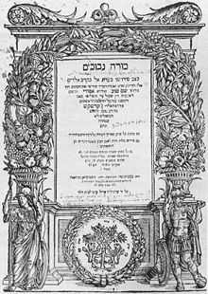
Title Page of the Rambam’s Moreh Nevuchim

He [the Rambam] wrote passages at the end of Mishneh Torah about the coming days of Moshiach, including censored comments about the role of Islam and Christianity in spreading the concepts of monotheism and moshiach. Recent editions of the Rambam, most notably the acclaimed Frankel edition are based on the original text and include these censored passages.
In his Guide, Rambam spells out a ‘rationalist’ approach. His views on good and evil, Divine providence and Divine knowledge remain the subject of much debate today. Divine providence – hashgacha pratis – is achieved by a person in proportion to their closeness to Hashem.
He [the Rambam] says that some evil – such as that due to inherent imperfections in our bodies and that caused by another person exercising free choice – should not necessarily be seen as Divine retribution.
The Rambam also wrote ten works of medicine and a treatise of logic as well as a number of highly significant letters such as Iggeres Teiman, a letter to the Jews of Yemen who were facing intense persecution and were under threat of forced conversions. His achievements are truly astounding and remarkable and left a lasting impact that is felt until today. As some of his contemporaries put it:
ממשה עד משה לא קם כמשה

Reprinted from the Parshas Korach 5779 email of Oneg Shabbos from London, England.

